**Creating Microservices for account and loan**

**Outputs and Results :**

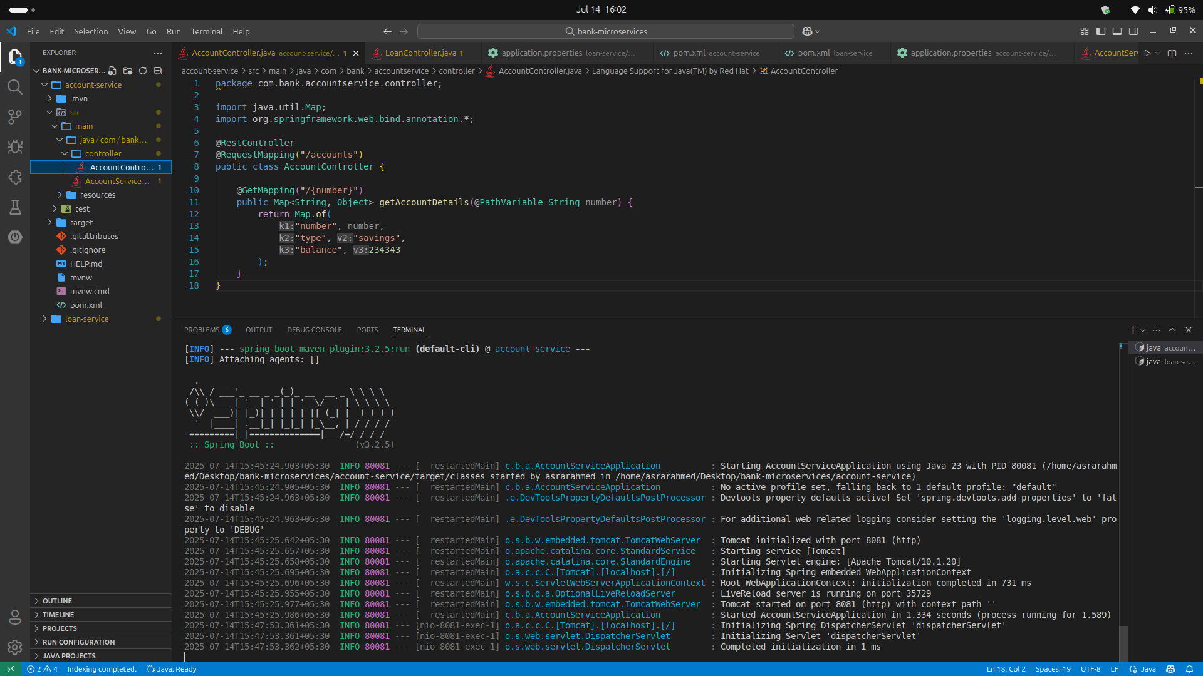**a:accountController**

**b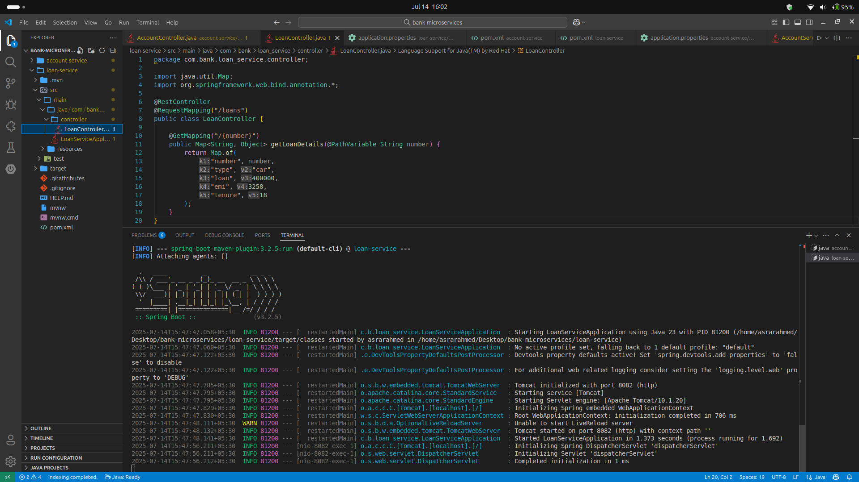:loansController**

**c:json account output**

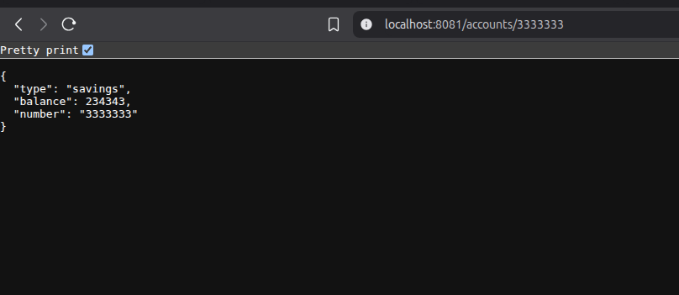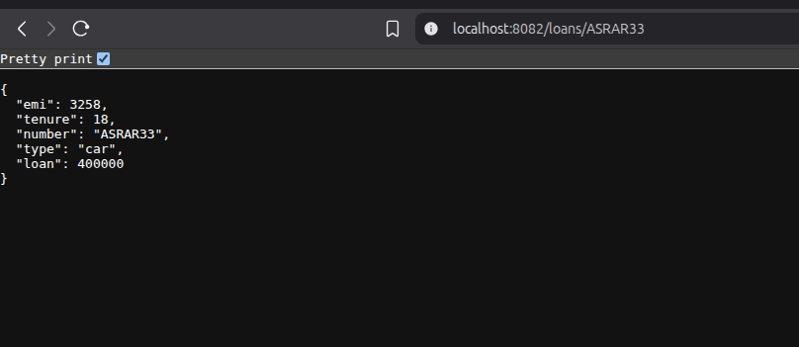

**d:json loans output**

**e:account-service run**

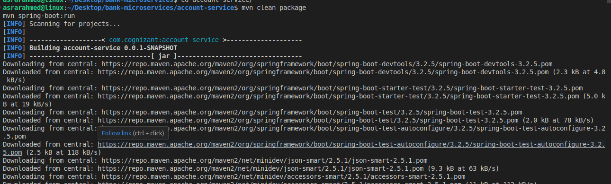

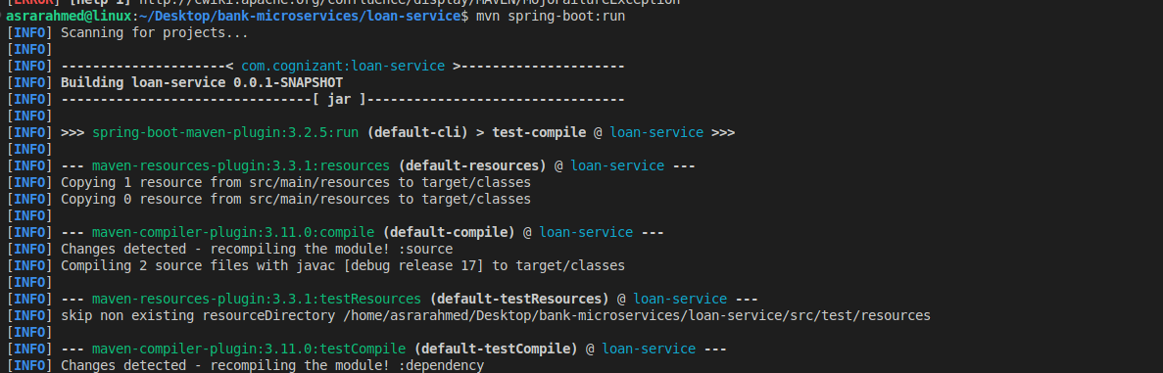**f:loan-service run**

**g:acccount port**

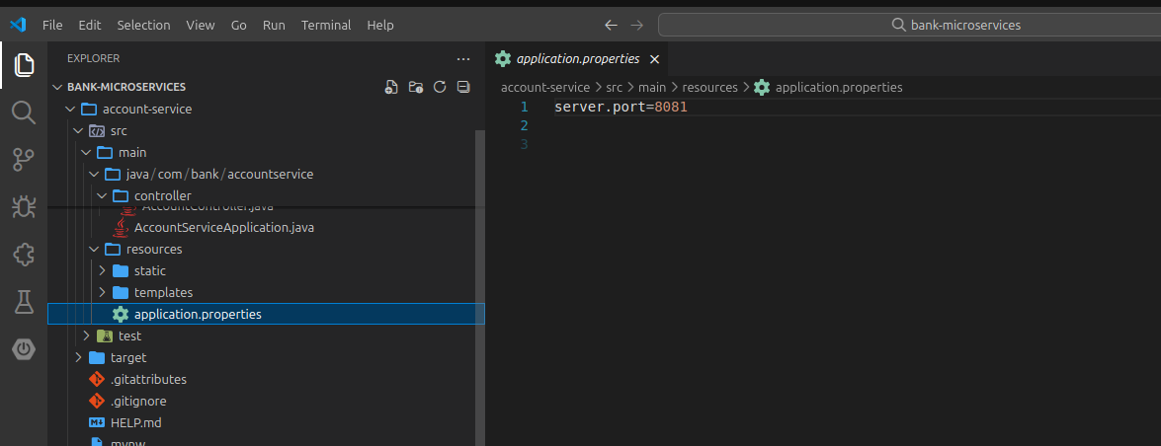

**h:loan port**

